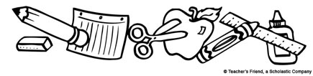
Crieve Hall Elementary School
2019-2020 School Year
2nd Grade Supply List

Please do not label any supplies.
- 2 package (12 or more) Ticonderoga pencils
- 24-count box of CRAYOLA Crayons (no RoseArt crayons!)
- Scissors
- 4 plastic folders with pockets, one each of the following solid colors: green, blue, purple, and red
- 3 wide ruled composition notebooks (About 70 pages each), one each of the following colors: red, blue, and black
- 1 thin cloth pencil-zipper pouch
- 1 3-ring binder (1 inch spine and with insert sleeve on cover)
- 4 pink pearl erasers (rectangular)
- 2 large glue sticks
- Earbuds
- 2 packages of skinny Expo Dry Erase Markers
2nd Grade Wish List
- 2 large boxes of Kleenex tissues
- 3 reams of white copier/printer paper (8 ½ X 11)
- 1 package of wide-ruled lined loose leaf paper
- 2 rolls of paper towels
- 2 containers of Clorox sanitary wipes
- 1 bottle of hand sanitizer
- 1 container of baby wipes
- 1 Pack of 3x3 Post-it Brand Post-it Notes

