This document highlights the vocabulary introduced throughout the primary curriculum – from K-6th grades
The vocabulary listed here is vocabulary that pupils are expected to use and understand on a daily basis within that year group, though the definitions are written for teacher reference and would not necessarily be shared with children as they stand. The vocabulary listed is cumulative and builds on the vocabulary previously introduced.
This is a working document and will be updated as required.

Common Words | Definition | Example
Above | Used to describe a higher position  than another object. | The Maths Meetings board is  above the sink.
Add | Carry out the process of addition. | I can add two numbers together  to find a total.
Addition | The operation to combine at least two numbers or quantities to form a further number or quantity, the sum or total. Addition is the  inverse operation to subtraction. | Three plus seven is equal to ten. This is an addition equation.
Altogether | In total. | That will be £2 altogether  please.
Balance | A measuring tool used to weigh objects. It has two dishes hanging on a bar. Both dishes will be level when the contents weigh the same. Also, as a verb, indicates equivalence and equality. | The objects in the balance are unequal in weight because the dish on the right side is lower down that the dish on the left side.  The two objects balance which means they have the same mass.
Before | In front of or prior to. | The number ‘3’ comes before ‘5’  on the number line.
Below | Used to describe a lower position than another object. | The sink is below the Maths Meetings board.
Between | Indicates a position in relation to two other places or objects on either side. | The teacher is standing  between two tables.
Capacity | The amount of liquid a container can hold. | This cup is full to capacity  because it cannot hold any more water.
Circle | The name of a 2-D shape. A circle has a curved side.
Clock | A tool used to measure time. | The clock shows us that the time  is now 2 o’clock.
Compare | Look for similarities and/or differences between at least two objects or sets. | I can compare these two sets –  this set has more.

Corner | A point where two or more lines  meet. The correct mathematical term is vertex (vertices). | The table has four corners  (vertices).
Cost | A monetary value assigned to a  good or service. | This apple costs 10p. What coin  could I use to pay for it?
Count | Assigning one number name to each of a set of objects to determine how many there are. | I counted the children in the group – there are four so we will need four pencils.
Cube | A 3-D shape with six identical square faces.
Cuboid | A 3-D shape with six rectangular faces.
Curved surface | A non-plane surface of a 3-D shape. Both cones and cylinders have curved surfaces. | The cone has a curved surface.
Cylinder | A 3-D shape with two circular faces joined by a curved surface.
2-D | Abbreviation for two-dimensional. A figure is two-dimensional if it lies on a plane. | A square is a 2-D shape.
3-D | Abbreviation for three- dimensional. A solid is three- dimensional and occupies space. | A cylinder is a 3-D shape.
Describe | To express mathematical features,  qualities and details in words. | Can you describe the properties  of a cube?
Difference | The numerical difference between two numbers or sets of objects. It is found by comparing the quantity of one set of objects with another. | The difference between ten and six is four.
Direction | The orientation of a line in space. | Which direction should we jump – forwards or backwards?
Distance | A measure between two points or things. | The distance between my house and the school is longer than that between the school and the train  station.
Double | To multiply by two or add a value to itself. | Ten is double five.
Edge | A line segment joining two vertices of a plane figure (2-D shape) and the intersection of two plane faces  (in a 3-D shape). | A triangle has three edges and a cube has 12 edges.
Empty | Containing nothing. Most commonly used in the context of measures. | There is no more water left in the jug – it is empty.
Equal | Indicates equivalence between two values and can be expressed with the symbol ‘=’. The symbol is read as ‘is equal to’ which means the | My sets are equal because there are four bears in this set and there are four bears in this set.

 | same as. Expressions on either side of the symbol have the same value.
Face | One of the plane surfaces of a solid  shape. | A cube has six faces.
Fewer | A lesser amount – used when counting discrete objects, i.e. countable objects such as, pens,  teddies, counters, etc. | There are fewer buttons on my coat than yours.
First | Comes before all others in time or position. | First I brush my teeth. Then I go to bed.
Flat | A level surface. | The table has a flat rectangular surface.
Full | Contains/holds as much or as many as possible; has no empty  space. | The juice carton is not full  because I drank some.
Group | To make equal size groups. This is one model for division. | I will group the crayons equally so that each person gets two.
Half | One of two equal parts of a shape, quantity or object. | I have shared the dolls into two equal groups – I have half and  you have half.
Intersection of sets | Where the two subsets overlap in a Venn diagram. Objects or values which belong to both subsets are placed here. | The number 4 belongs in the intersection because it is even and less than 5.
Last | Comes after all others in time or order. | Rory is the last person in the line.
Length | A linear measurement. | The length of my snake is shorter than yours.
Less | A smaller amount or not as much. | I have 15p and you have 7p. you have less money than me.
Line | A set of adjacent points that has length but no width. | I have drawn a line matching the number four with the four ducks.
Long | An adjective used to describe length. | I have a long piece of string.
Mass | A measure relating to the amount of matter within a given object. | The mass of the school bag is greater than the mass of the  book.
Measure | To find the size of something in a given unit. | How might we measure how much flour we need to bake a cake?
Minus | A name for the symbol ‘-’, which  denotes the operation of subtraction. | Three minus one is equal to two.
More | A greater amount. | I have six apples and you have  two. I have more.
Next | Comes immediately after the present one in order. | The next shape in my pattern is a square.
Number bond | A pair of numbers with a given  total. | Five and four make a number  bond to nine.
Number line | A linear, continuous representation of number. Each number occupies a point on the line, and there is an equal interval between each  number. | This number line starts at zero and ends at ten.

Number track | A linear, discrete representation of  number. Each number is positioned in a square on the track. | I can count from one to ten, moving a counter along this  number track.
Order | Describes the placement of items according to given criteria or in a pattern.  As a verb, to place items according to given criteria or in a pattern. | I have ordered the bears from smallest to biggest.
Pair | A set of two things used together. | Socks come in a pair – one for  each foot.
Pattern | A systematic arrangement of  numbers, shapes or other elements according to a rule. | The pattern is red, blue, red, blue, red blue.
Plus | The word representing the operation of addition. It is also the  name for the symbol ‘+’. | Five apples plus two apples are equal to seven apples.
Rectangle | A quadrilateral with four right angles.
Second | - A unit of time.  - An ordinal number. | Mohsin is second in the line today.
Sequence | A series of numbers or other elements which follow a rule. | The number 3 is next in the  sequence because each number is one less than the one before.
Set | A defined group of objects, numbers or other elements. | I have placed all the purple  counters in this set because they are all the same colour.
Share | To distribute fairly between a given number of recipients. This is one model for division. | I will share the crayons equally between the people at the table.
Short | An adjective used to describe length. | This string will not reach to the door. It is too short.
Side | A straight line that forms part of the boundary of a shape. | This shape has four straight  sides.
Size | An element’s overall dimensions or  magnitude. | The size of my shoe is smaller  than my teacher’s.
Sort | To organise a set of elements into specified categories. | I will sort these objects based on their size.
Square | A quadrilateral with four equal length sides and four right angles.
Straight | A line or movement uniform in direction, without bends or curves. | The walls of the school are  straight.
Subtract | Carry out the process of subtraction. | Nine subtract three is equal to six.
Subtraction | The inverse operation to addition. | We are taking some away so it is a subtraction question.
Sum | The result of one or more additions. | The sum of five and three is eight.
Surface | An outer boundary of a 3-D object. | This cone has a curved surface.
Take away | Used in the reduction structure of  subtraction. To remove a number of items from a set. | He ate three of the sweets so we  need to take away three counters.

Tall | Measuring a specific distance from top to bottom. | Our class teacher is not as tall as our head teacher.
Time | Related to duration. Measured in  seconds, minutes, hours, days, weeks, months, years etc. | After lunch it will be time for P.E.
Total | The sum found by adding. | There are a total of five people at this table.
Triangle | A polygon with three sides.
Venn diagram | Two or more circles which represent given sets and intersect according these. | 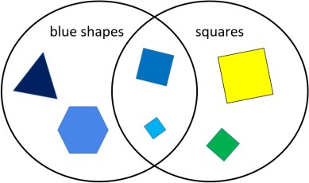
Vertex (pl.  vertices) | The point at which two or more  lines intersect. | This shape has five vertices.
Weight | The force exerted on an object by gravity. Weight therefore changes with a change in gravitational force. Used interchangeably with  mass until KS2. | The weight of this book is heavier than the pencil.
Zero | The number before one. It is neither positive nor negative. | Zero comes before one on the number track.

Year 1 | Definition | Example
Analogue clock | A clock with a face and hands. | 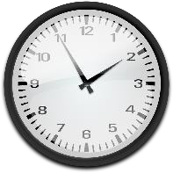
Anticlockwise / Counter Clockwise | Movement in the opposite direction to the motion of the hands of a clock. | 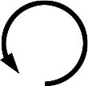
Approximate | The number is not exact but it is close. | Our PSHE lesson lasts  approximately half an hour.
Array | An arrangement of counters or numbers, in columns and rows, used to represent multiplication and division | This array  shows 3 × 4, 4 ×  3, 12 ÷ 4 and 12  ÷ 3

Block graph | The pre-cursor to the bar graph, this representation of data has an x- and y-axis and one block represents one item. Each block is adjoined to the adjacent block. | 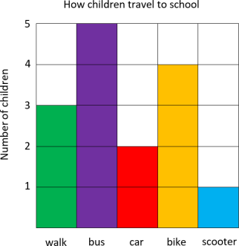
Chart | A table or graph. | I will mark one day for the sun on our weather chart.
Chronological | In time order. | I ordered the events in my day chronologically. I woke up, ate my breakfast, went to  school then came home.
Clockwise | Movement in the direction of the hands of a clock. | 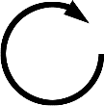
Cone | A 3-D shape with one circular plane face, which tapers to an apex. | 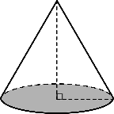
Continuous surface | An outer boundary of a 3-D object which is uninterrupted by any plane surfaces. | A sphere has a continuous surface.
Data | Quantitative information  which has been counted or measured. | This block graph shows us  data for the colour of the cars in the car park.
Decreasing | Becoming smaller in value. Used in relation to number sequences. | 15, 14, 13, 12. This number pattern is decreasing by one each time.
Diagram | An illustration, drawing or representation. | I will draw a diagram to show how I programed my floor toy to move.
Digit | One of the ten Arabic numerals 0 to 9, from which we compose numbers. | The number 54 has the digit five in the tens column and the digit four in the ones. The  digit five has a value of fifty.
Divide | To share or group into equal parts. | I can divide 12 by three using grouping or sharing.
Estimate | An appropriately accurate guess, depending on the  context and numbers involved. | I estimate there are eight cubes in the cup because it  looks about double four but fewer than ten.
Even number | A number with a 0, 2, 4, 6 or 8  in the ones and therefore exactly divisible by two. | 32 is an even number.
Facts | Related to the four operations (+, -, ×, ÷). Pupils should be supported in achieving | Number bonds to and within 10 and 20 are facts, e.g. 3 + 7  = 10.

fluency, i.e. very fast recall, in
these facts. These then become known facts.
Fraction | - A part of a whole number, quantity or shape.  - Expressing a division relationship between two integers in the  form ^{𝑎}.  𝑏 | I have shared my sweets into four equal parts. Everyone will get a fraction of the whole quantity of sweets. One group is a quarter of the whole.
Half turn | A 180 degree rotation, i.e. ¹ of  2  a 360 degree or ‘full’ turn.
Hour | A unit of time. | There are 24 hours in one day.
Increasing | Becoming greater in value. Used in relation to number  sequences. | 2, 4, 6, 8. This number pattern is increasing by two each  time.
Kilogram | A standard unit of mass, equal to 1000 grams. | The book has a mass of two  kilograms.
Known fact | A number fact which has been committed to memory (or very fast recall) and can be applied fluently to various calculation strategies. | When I use the ‘Make ten’ strategy to add, I use known facts to partition the number I’m adding.
Left | Indicating the position or direction. | Make a quarter turn left and walk forward three steps.
Litre | A standard unit of volume, equal to 1000 millilitres. | The capacity of the jug is about half a litre.
Mental calculation | A calculation performed without using a formal written strategy. Simple jottings may aid a mental calculation. | 14 plus 5 is equal to 19. I completed this using a mental calculation and deriving facts because I know  that four plus five is equal to nine.
Metre | A standard unit of measure, equal to 100 centimetres. | I estimate that the table is about a metre tall.
Minute | A unit of time. | We will have lunch in five  minutes.
Oblong | A quadrilateral with two pairs of parallel sides of equal length.
Odd number | An integer which is not  divisible by two without a remainder. | All numbers which end in 1, 3, 5, 7 and 9 are odd numbers.
Partition | To split a number into two or more parts. | The number 23 can be canonically partitioned (by place value) into 20 and 3, or non-canonically  partitioned in many

 |  | different ways, including 18 and 5, 17 and 6, etc.
Place value | A system for writing numbers, in which the value of a digit is defined by its position within the number. | In the number 452 written in base ten, the digit four has a value of 400, the five has a value of 50 and the two has a  value of two.
Position | Location, expressed either descriptively using positional prepositions, or specified by coordinates. | The book is on the table. The clock is hanging above the board.
Pound (sterling) | The official currency of the United Kingdom. | Pounds sterling are written using the £ symbol. There are 100 pence in one pound sterling.
Property | Any attribute. | A property of a triangle is that it has three straight sides and three vertices, the sum of  whose angles is 180 degrees.
Pyramid | A 3-D shape with a polygonal base and otherwise triangular faces, which form edges with the base, and which meet at  an apex. | 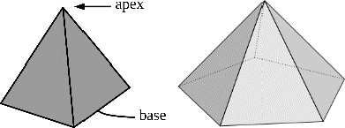
Quantity | An amount, in some cases given a numerical value. | A quantity of apples is placed on the left-hand side of the balance. How many kilogram masses will we need to place on the right to  balance the apples?
Quarter | One of four equal parts of a whole, quantity or object. | I have shared the eight conkers into four equal groups  – I have two conkers, which is one quarter of the whole.
Quarter turn | A 90-degree rotation, i.e. ¹ of  4  a 360 degree ‘full’ turn.
Repeated addition | A structure of multiplication where equal parts are added to make a whole. | I can show 4 × 5 as repeated addition: 4 + 4 + 4 + 4 + 4.
Repeated subtraction | A structure of division, where equal parts are subtracted and the number of equal parts summed to calculate a  quotient. | I can use repeated subtraction to calculate 20 divided by four: 20 – 4 – 4 – 4  – 4 – 4.
Represent | To express or show a mathematical concept using words, numerals and symbols, pictures, diagrams, or concrete manipulatives. | I have used three blue cubes to represent the three oranges in the question.  I used a part-whole model to represent the addition question.

Right | Indicating the position or direction. | The picture is on the right- hand side of the board.
Rule | A consistent pattern which allows generalisation.  Awareness of a rule allows a pupil to continue a sequence or generate a related  sequence. | 2, 5, 8, 11, 14…  The rule is that each number is three greater than the previous number. Therefore, the next number in this  sequence will be 17.
Scales | An object used to measure mass. | The scales showed that the banana had a greater mass than the apple.
Sign | Synonymous with symbol in its mathematical context, e.g.  +, -, ×, ÷, =. | 20 5 = 4. What is the missing sign?
Standard unit | A uniform measure, agreed upon as standard. | Standard units of mass include grams and kilograms. Standard units of length include centimetres, metres and kilometres.  Standard units of volume and capacity include millilitres and litres.
Sphere | A 3-D shape with a continuous surface, which is at all points equidistant from its centre. It has an infinite number of flat faces and straight edges. | A bowling ball is a sphere.
Symbol | Synonymous with sign in its mathematical context, e.g. +, -  , ×, ÷, =. | 20 5 = 4. What is the missing symbol?
Table | A structure organised into columns and rows, in which data can be recorded. | The information for Thursday is not yet complete on the table because it is only  Wednesday.
Turn | Rotation (see half and quarter turn). | A whole turn is 360 degrees. A half turn is 180 degrees. A quarter turn is 90 degrees.
Unit | - An element considered as a single entity. Ten single cubes can be grouped together to make a unit of ten.  - A unit of measure, which can be standard  or non-standard. | I regrouped ten ones for one  unit of ten.  Unifix cubes can be used as units of measure, but these are not standard units.
Volume | A quantity or amount of any substance and the 3-D space it fills. | The bottle contains a volume of one litre but its capacity is two litres. The bottle is half  full.

Year 2 | Definition | Example

Angle | The amount of turn, measured in degrees. | The angle is 60 degrees.
Calculate | To compute or work out  mathematically. | Can you calculate the  answer to 13 + 4?
Centimetre | A metric unit of length. | The book is 15 centimetres  long.
Column | A vertical arrangement of numbers or objects. | 23 has two tens – I will place them into the tens column.
Commutative | A property of addition and multiplication. It does not matter in which order the addends or factors are added or multiplied; the result will be the same. | 4 + 6 = 10  6 + 4 = 10  This demonstrates that addition is commutative. Arrays demonstrate the commutativity of multiplication, i.e. 3 × 4 = 4 ×  3
Consecutive | Following in order. | 2, 3, 4, 5, 6 are consecutive  numbers. 3, 6 and 9 are  consecutive multiples of 3.
Denominator | The number written below the vinculum in a fraction. In a measure context, it indicates the number of equal parts into which the whole is  divided. In a division context, it is the divisor. | In the fraction one quarter, four is the denominator.
Division | The process of partitioning a whole into equal parts. | 12 divided by 3 is equal to 4.
Efficient | Well-organised. Choosing an efficient computation strategy requires consideration of the numbers involved and will normally  utilise ‘known facts’. | I will use my number bonds knowledge to calculate 22 + 7 efficiently. I know that 2 + 7 is equal to 9, so the answer is  29. That’s more efficient that  counting on seven.
Frequency | The number of times something occurs within a data set. | 4 pupils have brown hair. The frequency of brown hair is 4.
Gram | A metric unit of mass. | The pencil weighs 20 grams.
Heptagon | A polygon with seven sides and seven angles.
Hexagon | A polygon with six sides and six angles.
Inverse operations | Opposite operations that  ‘undo’ each other. | Addition and subtraction are  inverse operations.
Millilitre | A metric unit of capacity/volume. | The can of fizzy drink has a capacity of 330 millilitres.
Multiple | The result of multiplying a number by an integer, for example, 12 is a multiple of 3 and 4 because 3 × 4 = 12. | 36 is a multiple of three because three multiplied by 12 is equal to 36. It is also a multiple of 12 for the same

reason (and 1, 2, 4, 6, 9, 18
and 36).
Multiplication | One of the four mathematical operations. Multiplication can be understood as repeated addition or scaling  (introduced in Year 3). | The multiplication symbol is ×.
Multiply | To increase a quantity by a given scale factor. | I can multiply 3 by 4 which is equal to 12.
Near double | When two numbers involved in an addition are close in value, such as 23 + 22. The numbers can be treated as exact doubles, followed by  compensating. | To calculate 23 + 22, I can use the near double strategy. I can double 22 and then add one more.
Non-unit fraction | A fraction with a numerator greater than one. | Two thirds is a non-unit fraction.
Numerator | The number written above the vinculum in a fraction. In a measure context, it indicates the specified number of parts out of the whole. In a division context,  it is the dividend. | In the fraction one quarter, one is the numerator.
Octagon | A polygon with eight sides and eight angles.
Operation | A mathematical process. The four mathematical operations are addition, subtraction,  multiplication and division. | 4 + 2 = 6. The operation is addition.
Pentagon | A polygon with five sides and five angles.
Pictogram | A representation of data using pictures or symbols. | 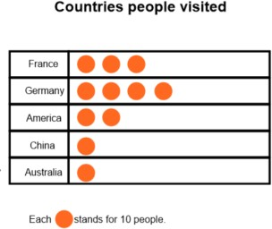
Quadrilateral | A 2D shape with four sides and four angles. which add up to 360 degrees.
Relationship | The way in which two or more things are connected. | The relationship between addition and subtraction is that they are the inverse of each other.
Right angle | An angle of 90 degrees. | A square has four right  angles.

Rotation | The act of rotating about an axis/centre. | I will rotate the square 90 degrees clockwise.
Scale | Equally spaced markings on a measuring device which can  be read to quantify a measurement. | Using the scale on the ruler, the book measures 15cm.
Symmetry | A shape is symmetrical when it fits exactly onto itself when folded in half. | This triangle has one line of  symmetry.
Tally | A form of counting. Each tally is a vertical mark. After the fourth vertical mark, a fifth horizontal/diagonal mark is drawn to create a group of  five. | Four children have black hair; I will record this as four tallies.
Temperature | The measure of heat. | Outside has a temperature  of 15 degrees Celsius.
Unit fraction | A fraction with a numerator of one. | One-third is a unit fraction.
Vinculum | A horizontal line that separates the numerator and the denominator in a fraction. | 1  vinculum  4

Year 3 | Definition | Example
Acute angle | An angle that is smaller than a right angle. | It is smaller than my right angle checker so this must be an acute angle.
Axis (plural: axes) | A real or imaginary reference line. The y-axis (vertical) and x-axis (horizontal) on charts and graphs are used to show the measuring scale or labels  for the variables. | The y-axis on this bar graph shows you how many pupils preferred each colour.
Bar graph | A representation of data in which the frequencies are represented by the height or length of the bars. | This bar graph shows us the preferred colours of the pupils in our Year 3 class.
Columnar addition/subtraction | The formal written algorithms for addition and subtraction that are exemplified in Mathematics Appendix 1 of the 2014  national curriculum. | Solve the following calculations by using the appropriate method of columnar addition or subtraction.
Factor | A number, that when multiplied with one or more other factors, makes a given number. | The number six has four  factors: 1, 2, 3 and 6.
Formal written methods | Exemplified in Mathematics Appendix 1 (see above). As | Pupils should only use  formal written methods

 | well as including columnar addition and subtraction, these also consist of written  algorithms for multiplication and division. | for calculations that cannot be efficiently calculated using mental strategies (with or without jottings).
Horizontal | Horizontal refers to planes  and line segments that are parallel to the horizon. | The x-axis on a graph should be horizontal.
Irregular | In geometry, irregular is a term used to describe shapes that are not regular (see below). | The sides and the angles of this pentagon are not all equal so the pentagon is irregular.
Kilometre | A metric unit measure of  length that is equal to one thousand metres. | The distance from the school  to Arun’s house was exactly  one kilometre.
Millimetre | A metric unit measure of length that is equal to one thousandth of one metre. | The length of Philippa’s ruler  is 300 millimetres.
Numeral | A numeral is a symbol (or group of symbols) used to  represent a number. | Whole numbers can all be represented as numerals  consisting of the digits 0 to 9.
Obtuse angle | An angle that is greater than a right angle but less than 180 degrees. | It is greater than my right angle checker so this angle must be obtuse.
Parallel | Line segments that can be described as parallel must be on the same plane and will never meet, regardless of how far either or both line  segments are extended. | The opposite sides of a square are parallel.
Perimeter | The perimeter of a 2-D shape is the total distance around its exterior. | I know that one side of this square is 2cm so it must have a perimeter of 8cm.
Perpendicular | A pair of line segments (or surfaces) can be described as perpendicular if they intersect at (or form) a right  angle. | The adjacent sides of a rectangle are perpendicular.
Place holder | A place holder is a zero used in any place value column (that contains a value of zero) to clarify the relative positions of the digits in  other places. | I need to use a place holder in the ones column to make it clear that my number is 320 and not 32.
Prism | A prism is a 3-D solid with two identical, parallel bases and otherwise rectangular  faces. | A triangular prism has five faces, consisting of three rectangles and two triangles  which are parallel.
Product | The result you get when you multiply two numbers. | 24 is the product of 3 and 8.
Regular | Regular 2-D shapes (regular polygons) have angles that | A square is a regular 2-D shape because all four angles

 | are all equal and side lengths that are all equal.  Regular 3-D shapes (the Platonic Solids) are those that have congruent (exactly the same) faces of a single  regular polygon. | are right angles and all four sides are the same length.  A cube is a regular 3-D shape with six identical square faces.
Roman numeral | Roman numerals are a system of symbols used to represent numbers that were developed and used by the Romans. They do not use a place value system. | The number twelve on this clock is represented by the Roman numerals XII, which is 10 + 1 + 1.
Round | Approximate a number, normally to the nearest multiple of ten, to make it  easier with which to calculate. | I would round the number 17 to 20 because it is three away from 20 but seven away from 10.
Square-based pyramid | A pyramid is a 3-D shape with a 2-D shape (which gives the pyramid its name) as a base and triangular faces that taper to a point called a vertex or apex. | This square-based pyramid has five faces; one square face and four triangular faces.
Triangle-based pyramid |  | This triangle-based  pyramid has four triangular faces.

Year 4 | Definition | Example
Area | The space a surface takes up inside its perimeter. Area is always measured in square units. | 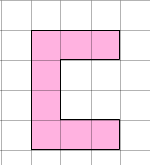  The area is 8 square units.
Associative properties | No matter how the parts in an addition or multiplication equation are grouped, the answer will be the same. | (6 + 3) + 2 = 11  6 + (3 + 2) = 11  Addition and multiplication are associative. Subtraction and division are not.
Convert | To change from one unit of measurement to another. | 2 km can be converted to metres  – it is equal to 2000 m.
Coordinate | The position of a point, usually described using pairs of numbers.  Sometimes called Cartesian coordinates, after the  mathematician Rene Descartes. | The coordinate (3,4) describes a point that is 3 on the x axis and 4 on the y axis.
Decimal fraction | A fraction expressed in its decimal form. | Half written as a decimal fraction is 0.5.
Distributive properties | The process whereby adding some numbers and then multiplying the sum gives the same answer as | 3 × (2 + 4) = (3 × 2) + (3 × 4)  3 × 12 = (3 × 10) + (3 × 2)

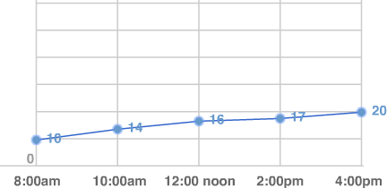
multiplying the numbers
separately and then adding the products.
Dividend | The amount that you want  to divide. | In ‘12 ÷ 3 = 4’, 12 is the  dividend.
Divisor | The number you divide by. | In ‘12 ÷ 3 = 4’, 3 is the divisor.
Equilateral | Having all sides the same length. | An equilateral triangle has three equal sides.
Equivalent | Equivalent means having the same value. Equivalent fractions have the same  value. | 2 1  =  4 2
Expression | One or a group of numbers, symbols or operators. An expression does not use equality or inequality signs. Using an equality or inequality sign will give an  equation. | 2 × 3  4²
Grid | A series of evenly divided and equally spaced shapes, usually squares. |  | 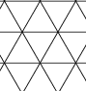
Improper fraction | A fraction where the numerator is bigger than the denominator. These fractions are therefore  greater than one whole. | 12  11
Integer | A whole number that can be positive or negative. | 6 is an integer, 0.6 is not.
Interval | An interval on a graph’s  axis lies between two values. | If one point on an axis is 50 and the next 60, the interval is 10.
Isosceles | Having two sides of equal length. Isosceles triangles have two equal sides; isosceles trapezia have two equal, non-parallel sides.
Kite | A 2-D shape with two pairs of equal length adjacent sides. The diagonals intersect at right angles. | 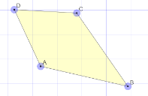
Line graph | A graph that uses lines to connect the points on a data chart.  Used to present continuous data, such as change over time. | Temperature graph
Mixed numbers | Numbers consisting of an integer and fractional part. | 1 ¹; 3 ³  2 4
Negative number | A number that is less than zero. (It is helpful to refer  to these numbers as | -1, -24, -o.5 etc.

‘negative numbers’ rather than ‘minus’ to avoid confusion with the
operation ‘minus’.)
Parallelogram | A 2-D shape that has two pairs of parallel sides and  equal opposite angles.
Plot | To mark out a point on a graph or grid. | ‘Plot the point (3,6)’ means to draw the precise location of that point, usually shown as a dot or a small cross.
Point | The precise location of a position on a 2-D plane. | An exact place on a graph or on squared paper. A point is often represented by a capital letter.  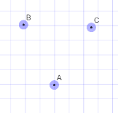
Positive number | A number that is greater than zero. Zero is neither positive or negative. | 3, 32, 0.5
Proper fraction | A fraction with a value less than one. | 1 , 3, 5  2 4 8
Protractor | A measuring device for measuring the size of an angle. Angles are measured in degrees (°). | 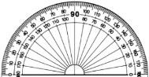
Quotient | The result when the dividend is divided by the divisor. | 15 ÷ 3 = 5  5 is the quotient.
Rectilinear | A rectilinear shape has straight line edges which are perpendicular (all meet at right angles). | A rectangle.  A straight-sided shape that can be divided up into other rectangles.
Rhombus | An equilateral parallelogram with four equal length sides.
Scalene | A scalene triangle has three unequal sides and three unequal angles.
Short division | A formal written layout where the quotient is calculated showing only one written step. | 7 7  5 3 8 5
Short multiplication | A formal written layout where the multiplier is usually 9 or less. | 782  × 9  7038

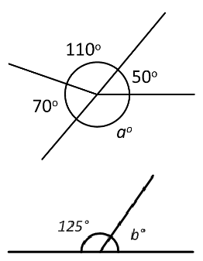
Simplify | To write a number or  equation in its simplest form. | I can simplify ⁸ to ⁴.  10 5
Square centimetre | A unit of measure for area equal to a square with the  dimensions 1 cm by 1cm. | Sometimes referred to as centimetre squared, abbreviated  to cm².
Trapezoid | A quadrilateral with exactly one pair of parallel sides.

Year 5 | Definition | Example
Angle at a point | Angles that meet at a point that sum to 360°.
Angle on a line | Angles formed on a straight line that sum to 180°.
Average (mean) | A measure of central tendency. The mean average of a set of data is the sum of the quantities divided by the  number of quantities. | The mean average of the set 4, 5, 5, 6 is 5 because (4 + 5 + 5 + 6)  ÷ 4 = 5.
Common factor | A factor of two (or more) given numbers. | A common factor of 12 and 9 is 3 because 3 × 4 = 12 and 3 × 3 =  12.
Common multiple | A multiple of two (or more) given numbers. | A common multiple of 3 and 6 is 12 because 3 × 4 = 12 and 6 × 2  = 12.
Congruent | Used to describe two shapes or figures which are exactly the same size. | The two triangles are congruent. If I place one on top of the other, there is no overlap.
Cube number | The product of three equal factors. | Eight is a cube number because 8 = 2 × 2 × 2 = 23.
Cubic centimetre | A unit used to measure volume. The space taken up by a cube with edges of length 1 cm or which measures 1 cm × 1 cm × 1  cm. | The volume of this multilink cube is eight cubic centimetres.
Cubic metre | A unit used to measure volume. The space taken up by a cube with edges of  length 1 metre. | The volume of this fridge is two  cubic metres.
Decagon | A polygon with ten sides and ten angles.

Degree | The unit of measure for angles. | A right angle is 90 degrees.
Diagonal | A straight-line segment that joins one vertex to another. | The diagonals of a kite are perpendicular
Divisible | A number is said to be divisible by another if it can be divided by that number without a remainder. | 24 is divisible by 8. When divided by 8 it gives a quotient of 3, with no remainder.
Dodecagon | A polygon with twelve sides and twelve angles.
Long division | The formal written algorithm that can be used to divide by a number with two or more digits. | 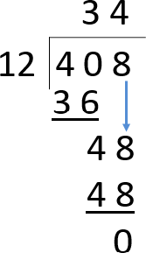
Long multiplication | The formal written algorithm that can be used to multiply a number by a number with two or more digits. | 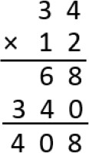
Negative integer | A whole number with a value less than zero. Zero is neither positive nor  negative. | When the temperature falls below 0° a negative integer is used to record it.
Nonagon | A polygon with nine sides and nine angles. | 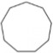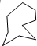
Percentage | The number of parts per hundred which is written using the % symbol. | 30% means for every 100 there  are 30.
Polygon | A 2-D shape with three or  more straight sides. | Triangles and rectangles are  examples of polygons.
Polyhedron (pl. polyhedra) | A 3-D shape with flat surfaces that are polygons. | A cuboid is a polyhedron.  A cylinder is not a polyhedron  because it has a curved surface.
Prime factor | A factor that is a prime number. | 3 and 2 are prime factors of 6.
Prime number | A whole number with only two factors, one and the  number itself. | 2, 3, 5, 7, 11, 13, 17 and 19 are the  prime numbers less than 20.
Remainder | The amount remaining after division when a whole number answer is needed. | 21 divided by four is equal to five with a remainder of 1.

Reflection | A mirror image that is equidistant from a mirror line. | The shape has been reflected in the dotted mirror line.  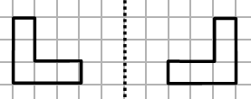
Reflex angle | An angle that is greater than 180°. | 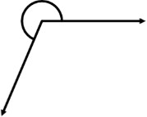
Scale (not to scale) | The ratio of lengths, in a drawing, are in proportion to the measurements of the real object.  The lengths are not in proportion when not to scale. | The diagram was not drawn to scale. That means I can’t use a ruler to measure the sides, because they are not in proportion to the real object.
Square metre | A unit of measure for area. The surface covered by a square with sides of length  one metre. | The area of the floor in a room might be measured in square metres.
Square number | The product of two equal factors. | 9 is a square number because 9 = 3 × 3 = 32.
Tetrahedron | A 3-D shape with four triangular faces. | 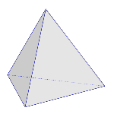
Transformation | A collective term for the ways that shapes can be changed, resulting in congruent or similar shapes,  i.e. translation, reflection, rotation or enlargement. | Translations and reflections are types of transformations.
Translation | When a shape moves so that it is in a different position but retains the same size, area, angles and side length and so is congruent. | Triangle C has been translated three right and two down resulting in triangle D.  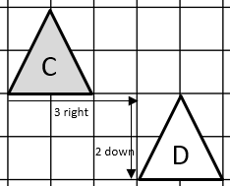

Year 6 | Definition | Example
Arc | A portion of the circumference of a circle | 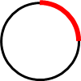

Brackets/ parenthesis | The symbols ( ) used to  separate parts of a multi-step calculation. | (10 – 2) × 3 = 21
Centre | In a circle, the centre refers to one point that is equidistant to all points around the  circumference of the circle. | To draw a circle, I place the point of my pair of compasses at the centre.
Circumference | The perimeter/boundary of a circle.
Compasses | A tool for creating curved lines, arcs and circles. | I can use a pair of compasses to draw a circle with a radius of 4 cm.
Common fraction | A fraction written with a  numerator and denominator separated by a vinculum. | One quarter can be written as  a common fraction, ^{𝟏}.  𝟒
Degree of accuracy | A description of how accurately a value is communicated. | The degree of accuracy needed for the answer is one decimal place.
Diameter | A line from one point of the circumference of a circle to another on the opposite side, which must pass through the centre of the circle. | The circumference of a circle is the diameter multiplied by pi.  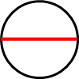
Equivalent expression | An expression, which can be algebraic, which is equal in value to another expression. | Find an equivalent expression to 17 + 10. 18 + 9 is an equivalent expression  to 17 + 10.
Factorise | To identify factors of a given number. To express a number as factors. | I can factorise 12 by looking at its factor pairs. 1 × 12 = 12,  2 × 6 = 12, 3 × 4 = 12. So the  factors of 12 are 1, 2, 3, 4, 6  and 12.
Foot/feet | A standard unit of measure of length. | I am approximately five feet  tall.
Formula | An algebraic expression of a rule. | The area of a rectangle can be found by multiplying the width and height.  a = w × h
Gallon | An imperial unit of measure  of volume/capacity. | A gallon is approximately 4.5  litres
Standard or Imperial unit | A unit of measure officially used in the US.  Includes miles, pounds and pints. | Miles are an standard unit to measure length.

Inch | A standard unit of measure. | An inch is approximately 2.2 cm.
Intersect | The point at which two (or  more) lines meet is where they intersect. | The x and y axes intersect at (0,0)
Metric unit | A standard unit of measure used in the UK and Europe. Includes centimetres, litres and kilograms. | Litres are a metric unit used to measure volume.
Mile | A standard unit of measure  of length. | Five miles is equivalent to  eight kilometres.
Net | A group of 2-D shapes which, when folded and connected, forms a 3-D polyhedron. | The net of a cube is comprised of six connected squares.
Order of operations | The internationally agreed order to complete operations in a multi-step equation with multiple operations. | (3 + 4) × 2 = □  The order of operations dictates that the operation within the brackets is completed first.
Origin | The point at which axes in a coordinates grid cross; the point (0,0). | 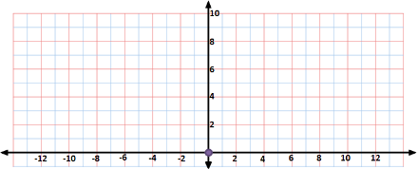  The origin is indicated by the blue dot.
Ounce | An standard unit of measure  of mass. | The newborn baby had a mass  of 6 pounds and 3 ounces.
Pie chart | A representation of a set of data where each segment represents one group in proportion to the whole. |  | Nationality of Astronauts on Board ISS January 2017  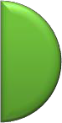  Russia USA France
Pint | A standard unit of measure. | I found a pint of milk on my doorstep.
Pound (mass) | A standard unit of measure of mass. | The new-born baby had a  mass of 6 pounds and 3 ounces.
Proportion | A comparison between two or more parts of a whole or group. Proportion expresses a part-whole relationship. This may be represented as a  fraction, a percentage or a decimal. | Two thirds of a class were boys. The proportion of the class that is girls is one third.

Quadrant | One of four regions into which a coordinates grid is divided. | 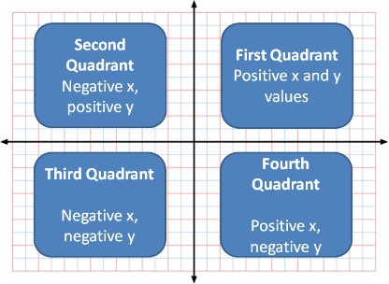
Radius | A line from one point of the circumference of a circle to the centre of the circle. | 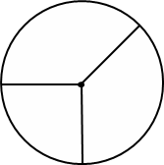
Ratio | A comparison between two or more parts of a whole or group. Ratio expresses a part- part relationship. This is usually represented in the  form a:b. | For every 4 tulips there are 7 daffodils. The ratio of tulips to daffodils is 4:7.
Similar | Similar shapes are those which have the same internal angles and where the side lengths are in the same ratio or proportion. Enlarging a shape by a scale factor (for example by doubling all side lengths) creates a similar  shape. | All squares are similar to one another.
Square millimetre | The area of a square with sides 1 mm. | The smallest squares on graph paper have an area of one square millimetre.
Square kilometre | The area of a square with  sides 1 km. | The area of England is 130 279  square kilometres.
Vertically opposite angles | Angles which are positioned opposite to one another when two lines intersect. | 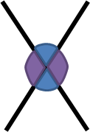  The purple angles indicated are vertically opposite angles.

